



**SM6P07 Digital Media Project**

**50% Individual Coursework**

**2024-25 Autumn**

**Student Name: Avinash Gyalzen Lama**

**London Met ID:** 22068804

**College ID: np01mm4a220101**

**External Supervisor: Bibek Gurung**

**Internal Supervisor: Dibesh Maskey**

**Assignment Due Date: Wednesday, May 7, 2025**

**Assignment Submission Date: Wednesday, May 7, 2025**

**Word Count: 2227**

**Project File Links:**

|  |  |
| --- | --- |
| **YouTube Link:** | Keep Unlisted YouTube URL of your Project Here |
| **Google Drive Link:** | Keep Google Drive URL of your Project Here with Anyone in Organization can View Option Enabled |
| **Github Link:** | **https://github.com/Pyroknightsushi/Final-Year-Project** |
|  |  |

*I confirm that I understand my coursework needs to be submitted online via Google Classroom under the relevant module page before the deadline in order for my assignment to be accepted and marked. I am fully aware that late submissions will be treated as non-submission and a marks of zero will be awarded.*

# Abstract

The project is a short 3D video of a game environment. The video is going to showcase all the 3D assets in the environment by following the trail of a cat. This project will help showcase the talents the student has in terms of 3D modelling, rigging and animation.

# Introduction

## Topic

Neon Echoes

## Area of Research

The research topic is to create a 3D animation that answers the question of does environmental storytelling, lighting, and texture design in a 3D space enhance player immersion and emotional engagement in narrative-driven games.

# Aim of Project

A short 3D animation video showcasing an environment along with all the assets in a 3rd person perspective. The objective of the project is to showcase all the skills the student has learned from modelling, UV mapping, texturing, animation. This will also be part of the student’s portfolio for the future.

# Target Audience

Title

Neon Echoes

Tagline

A world forgotten, rediscovered through the eyes of a wanderer

Genre

Sci-Fi Adventure

Post-Apocalyptic Exploration

Storyline

A cat’s journey through breathtaking environments, revealing glimpses of the past.

Target Audience

Age: 16+

Gender: Any

Experience

Immersive Visuals

Emotional Atmosphere

Cinematic Quality

# Product Research

## Character Modelling

For character modelling this tutorial was followed.

Youtube Link: <https://youtu.be/4JvuY3GTPRM?si=T4T_tDHnRIsGGuD7>

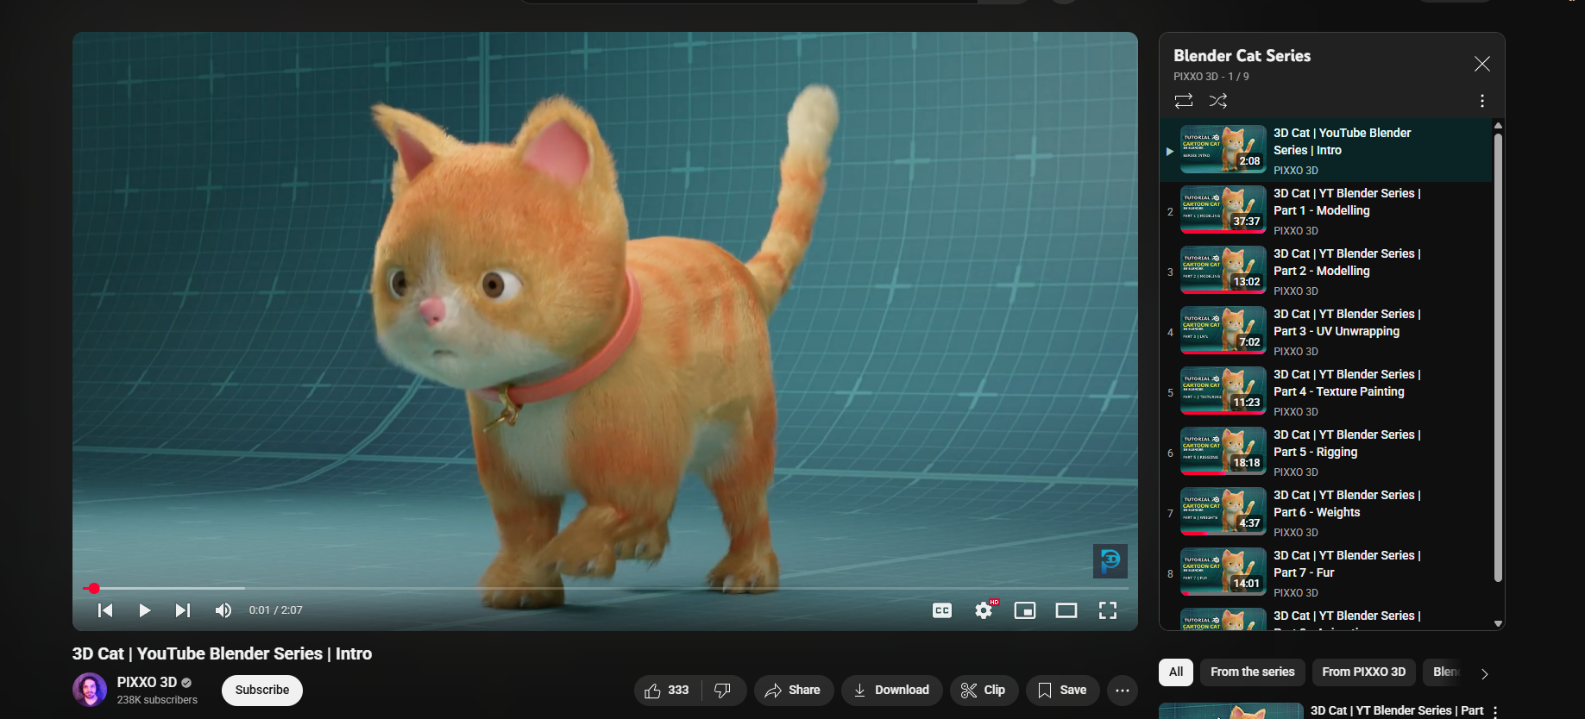

Figure 1 Research on character modelling

## Character Rigging

For rigging the character this guide was taking as reference.

Youtube Link: <https://www.youtube.com/watch?v=eucOLC2sOmk>

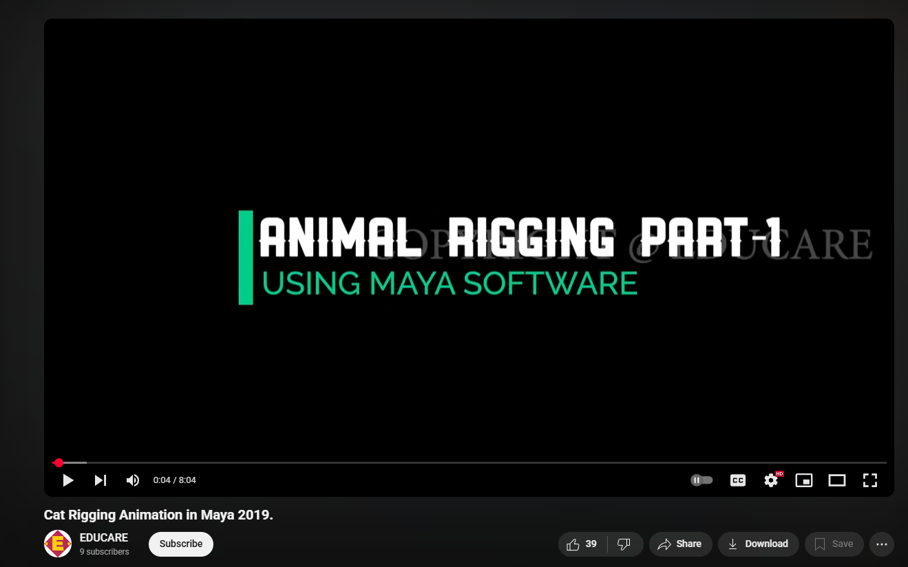

Figure 2 Research on Character rigging

## Character Texturing

This video was taken as reference for Character texturing research/

Youtube Link: <https://www.youtube.com/watch?v=WDsRtJTc_48>

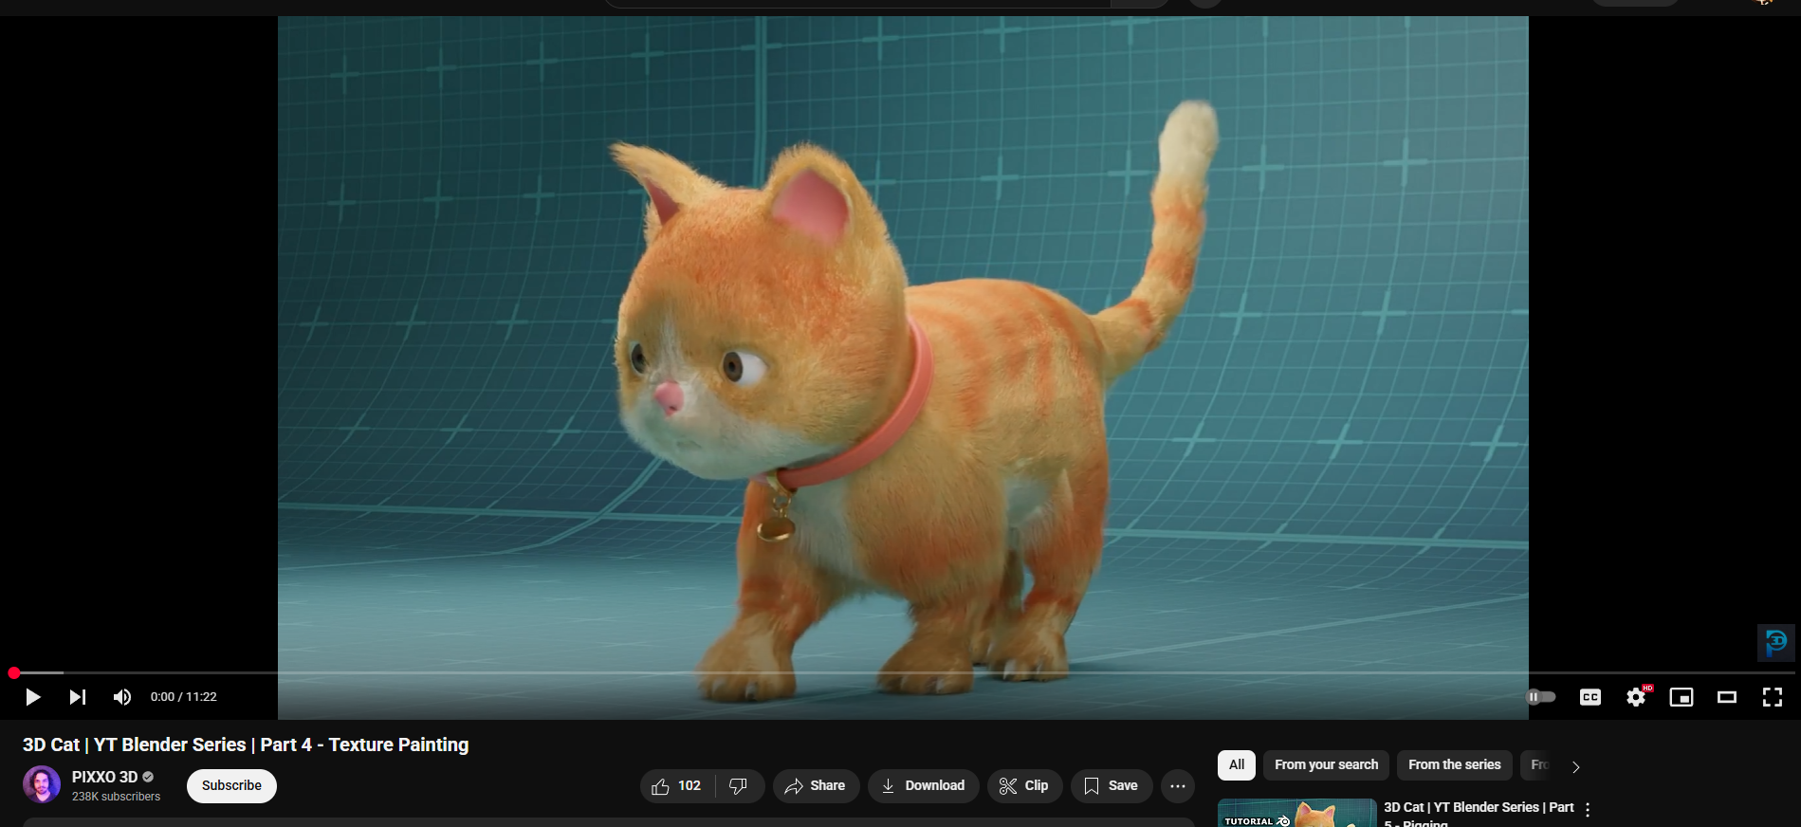

Figure 3 Character Texturing Research

## XGen Hair Research

This video was used to research on how groom able hair is created in Maya with the use of XGen.

Youtube Link: <https://www.youtube.com/watch?v=x0w4XpZqSCA>

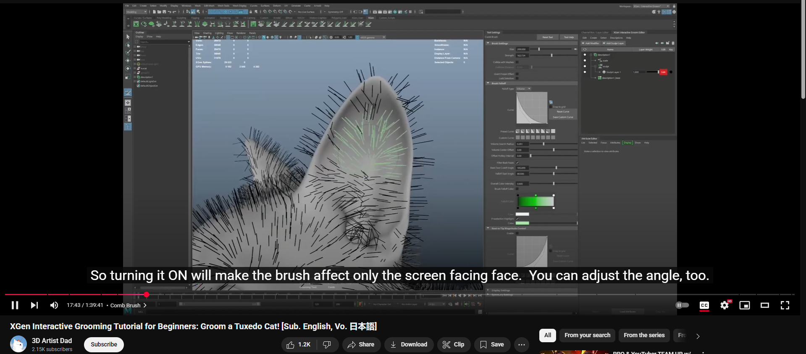

Figure 4 Xgen Hair Research

## Environment Modelling

For environment modelling this video was taken as a reference.

Youtube Link: <https://www.youtube.com/watch?v=56xMeqWXjSg>  
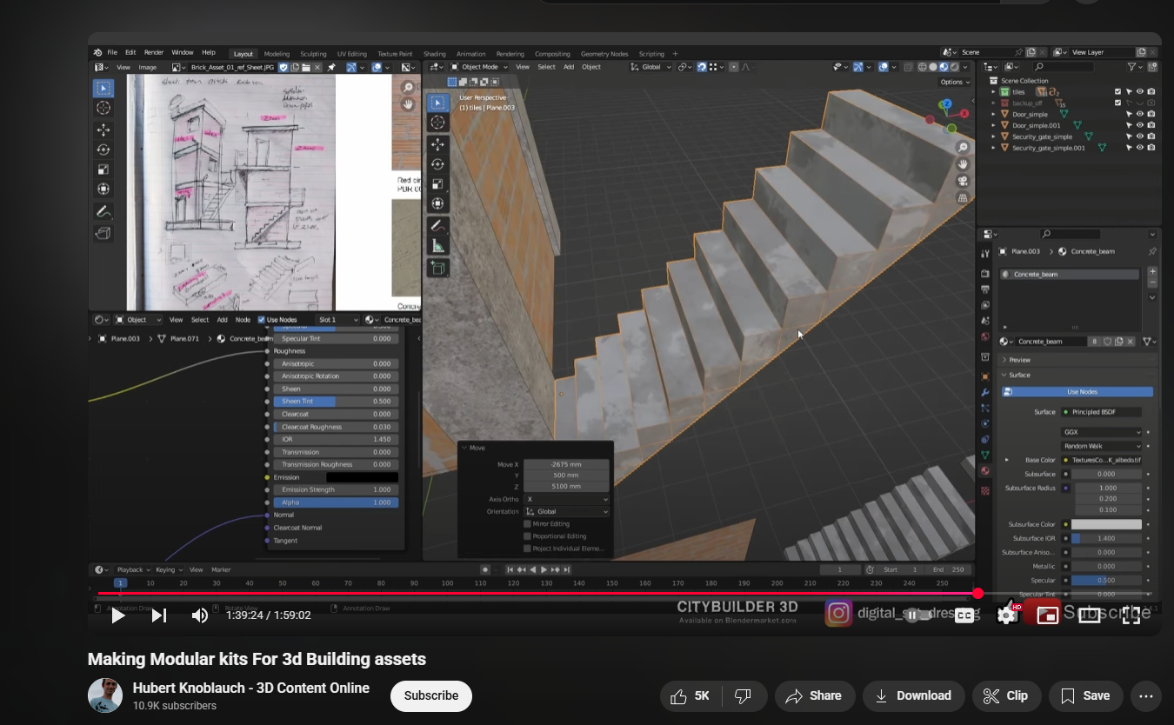

Figure 5 Environment Modelling Research

## Box Mapping

This video was used as research for Box Mapping in blender/

Youtube Link: <https://www.youtube.com/watch?v=vyNm3I16rHg>

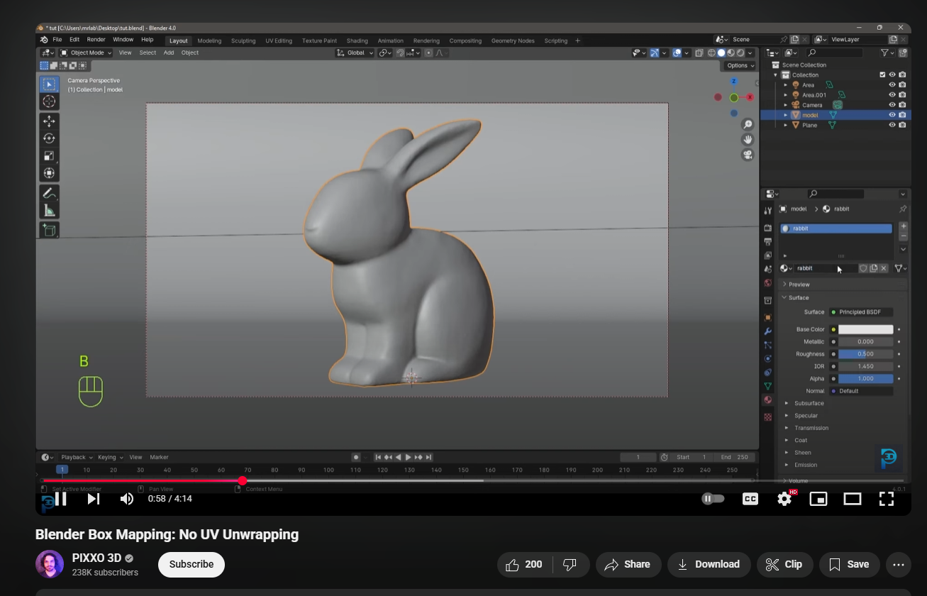

Figure 6 Box Mapping Research

## Character Animations

This video was used as reference for character animations.

Youtube Link: <https://www.youtube.com/watch?v=v7KANqGGis4>

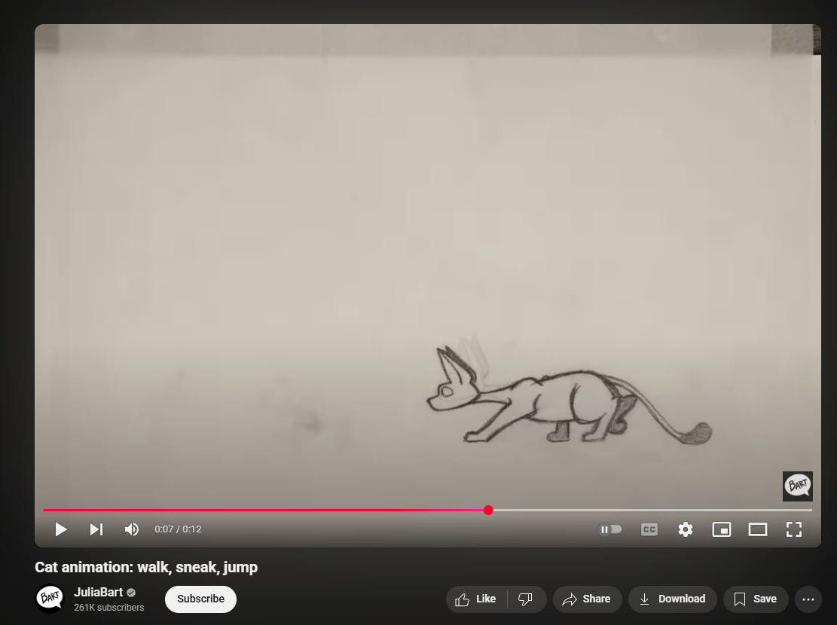

Figure 7 Character Animation Research

## 2D Image to 3D Model

This video was taken as reference to create 3D polygons from 2D images in blender.

Youtube Link: <https://www.youtube.com/watch?v=BcjPCjxsCZo>

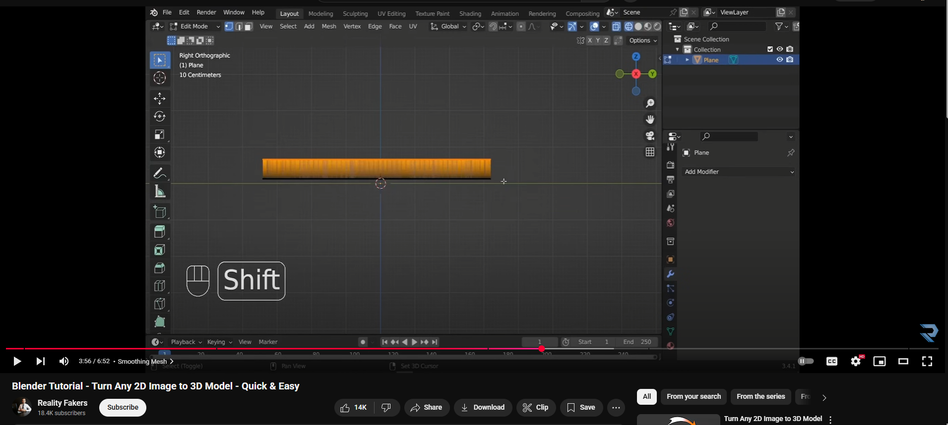

Figure 8 2D Image to 3D Model Research

## Creating Wires/Cables using Curves

This video was used to research into making wires/cables quickly using Curves.

Youtube Link: <https://www.youtube.com/watch?v=4igTVJOEJw0>

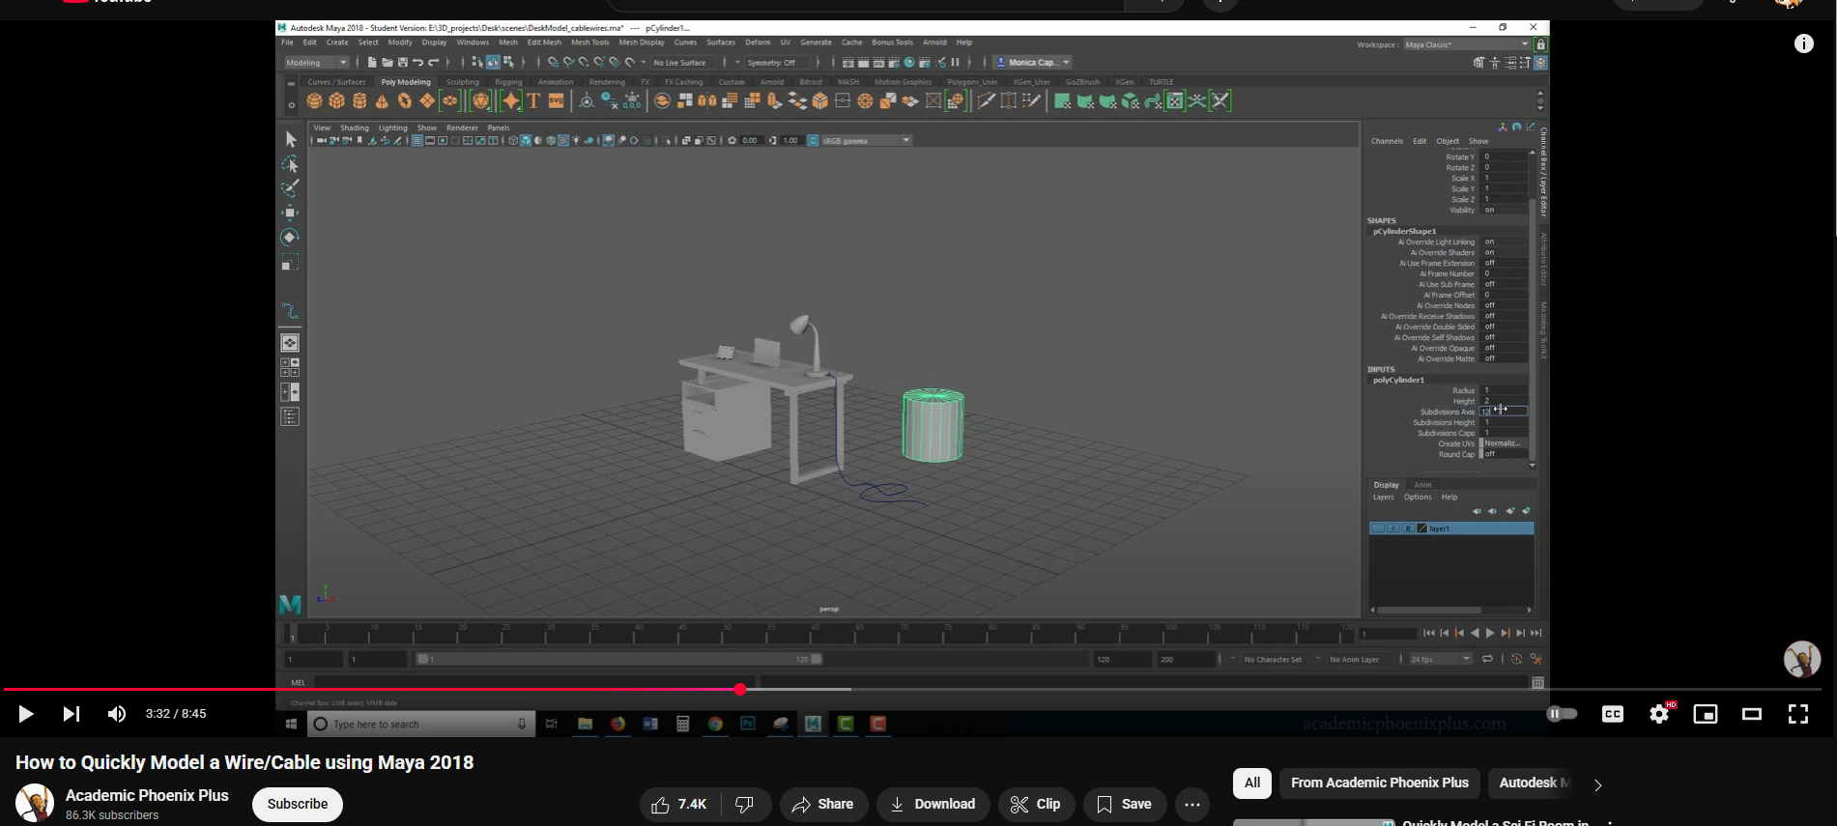

Figure 9 Creating Wires/Cables using Curves Research

## Creating Neon Signs

Research into a quick and easy way on how to create neon signs on blender using text

Youtube Link: <https://www.youtube.com/watch?v=8eNN2Ep3Rqs>

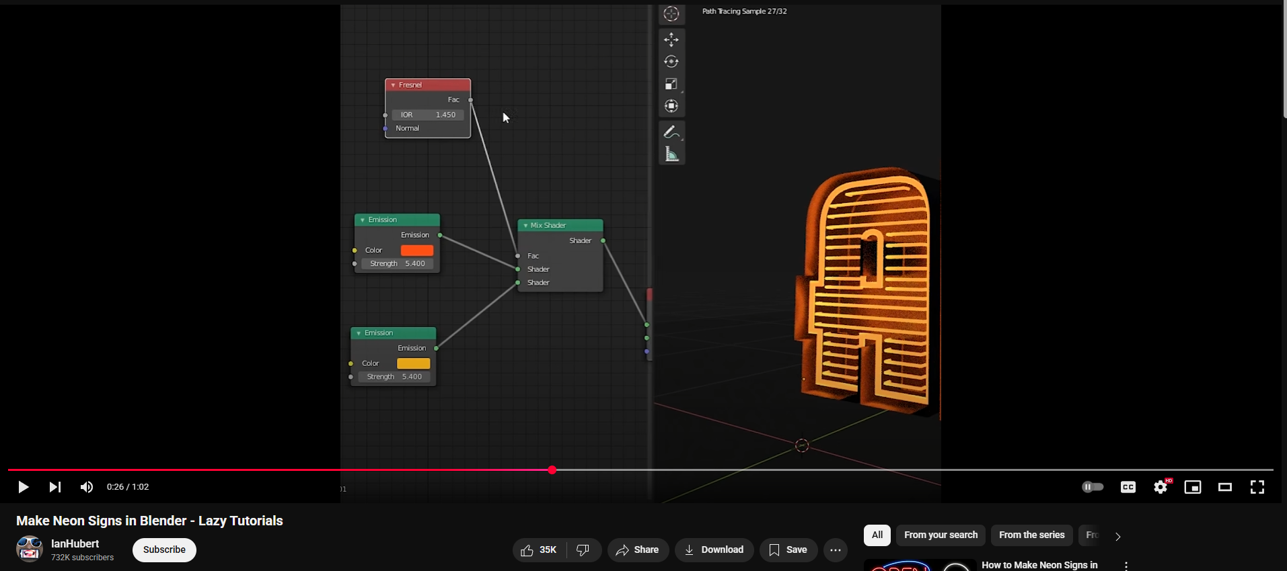

Figure 10 Research into creating neon signs

## Creating Fur with nHair

Research into how to create a simple hair system using nHair

Youtube Link: <https://www.youtube.com/watch?v=tNZcI_3iFUI>

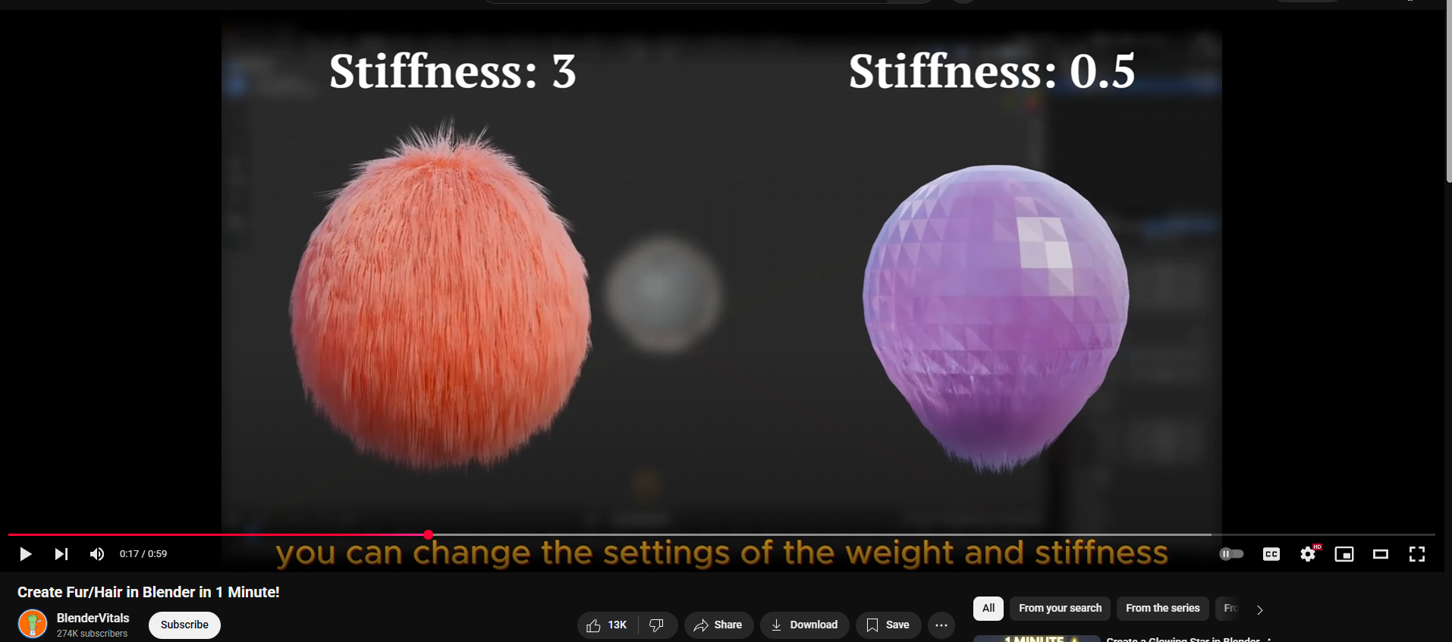

Figure 11 Research into creating hair with nHair

## Adding Glow to Objects

Research into adding glow to any object.

Youtube Link: <https://www.youtube.com/watch?v=WTFj9B6eFgk>

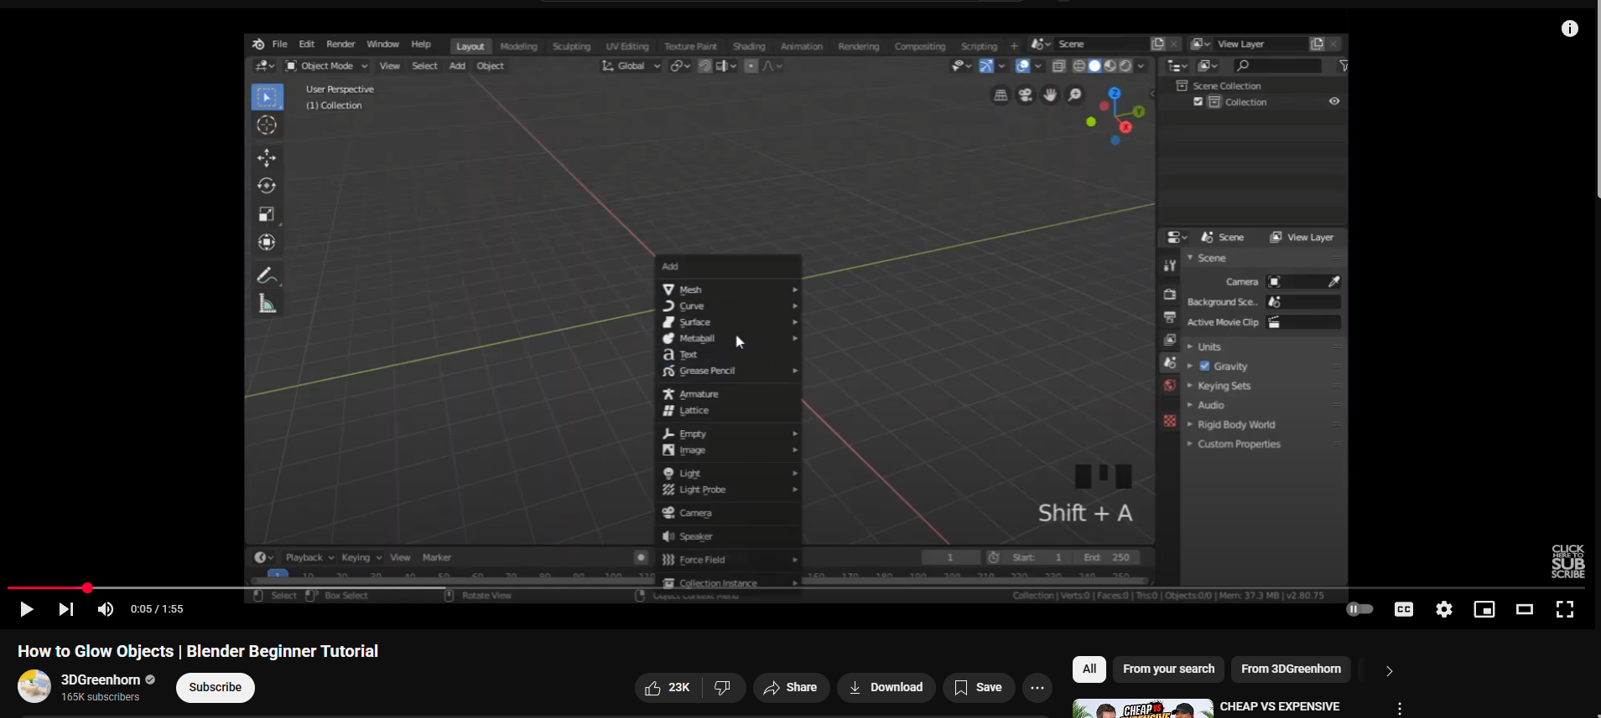

Figure 12 Research into adding glow to objects

# Technologies Employed

### Maya

Used to model the character, animation, lighting, texturing, and rendering.

### Blender

Used for environment modelling, box mapping the environment, along with scene setup with the help of minor assets that were downloaded.

### Adobe Photoshop & Substance Painter

Used for storyboard, texturing of assets.

### After Effects

Used for creating post-production effects.

### Premiere Pro

Compiling footages from the scenes, adding ambient music, exporting the final output

# Project Plan

The project timeline had to be changed as the deadline was closer than expected. So, adjustments were according to that. Animation took shorter than expected while documenting everything took a while but since animation didn’t make as much time it was easier to meet deadlines.

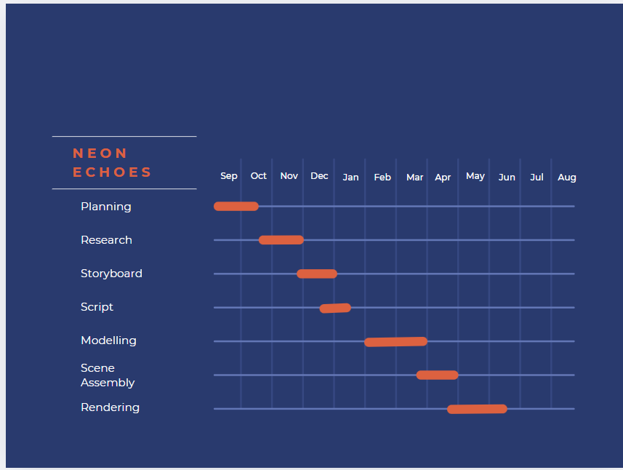

Figure 13 Old Gantt chart

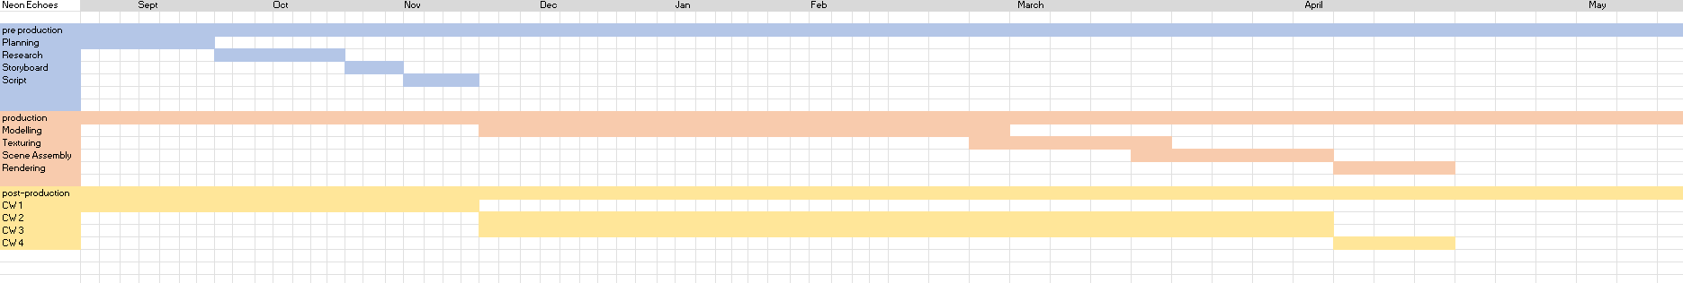

Figure 14 New gantt chart

# Character Design

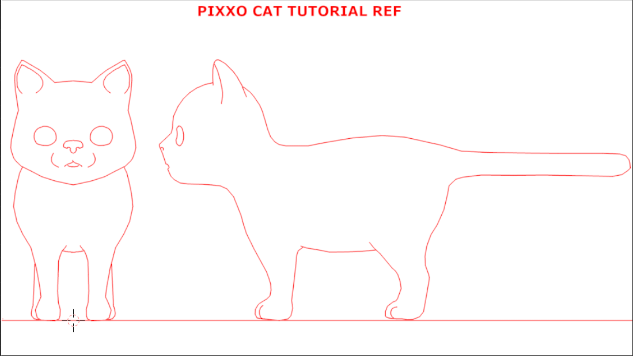

Figure 15 Character Design

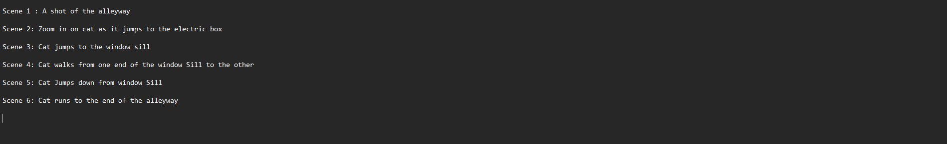

Figure 16 Rough Script

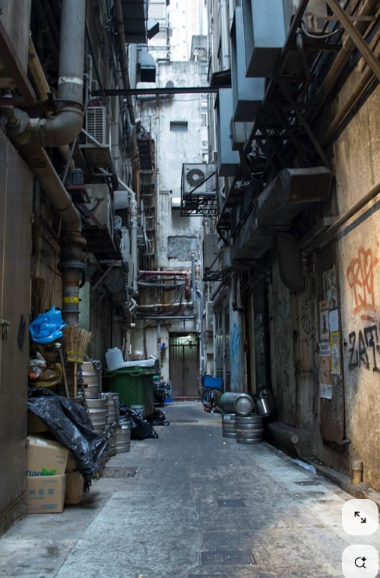

Figure 17 Environment

# Storyboard

# Production Stage

## Character Modelling and Texturing

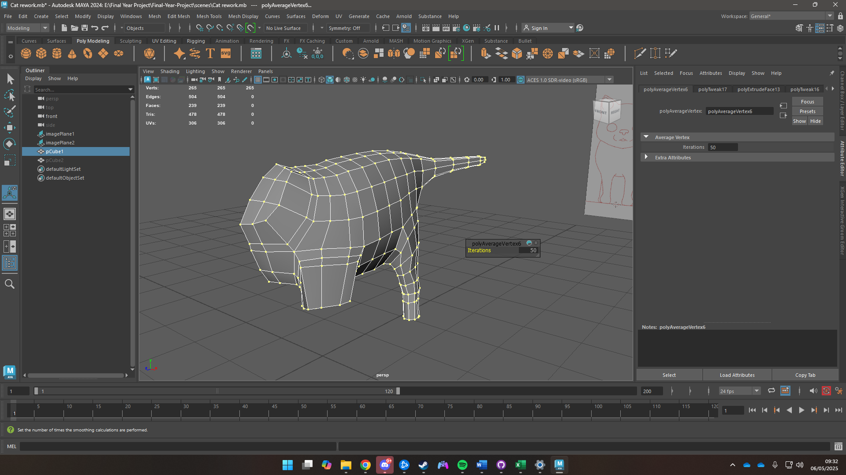

Figure 18 Character Modelling 1

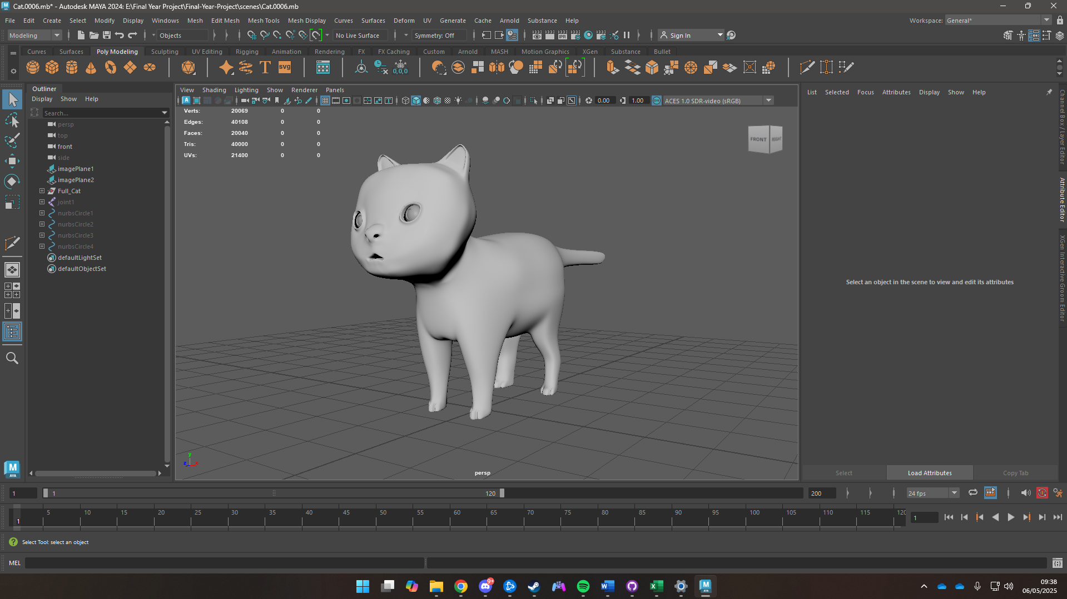

Figure 19 Character Modelling 2

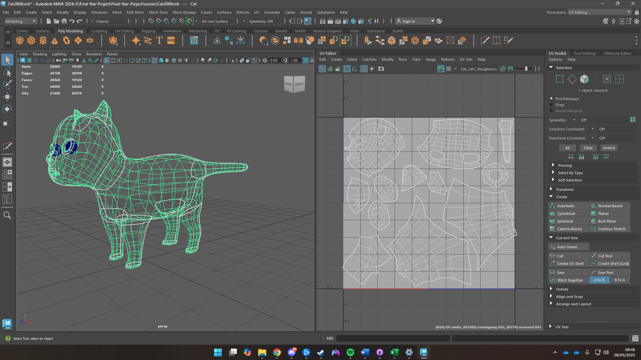

Figure 20 UV Unwrapping

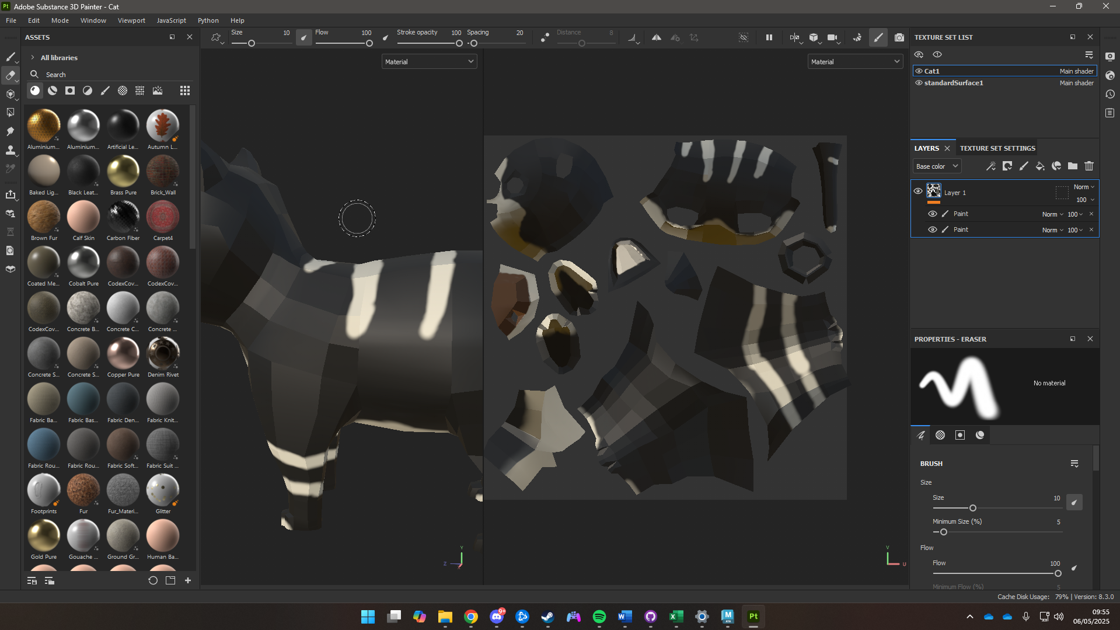

Figure 21 Texturing Character

## Rigging

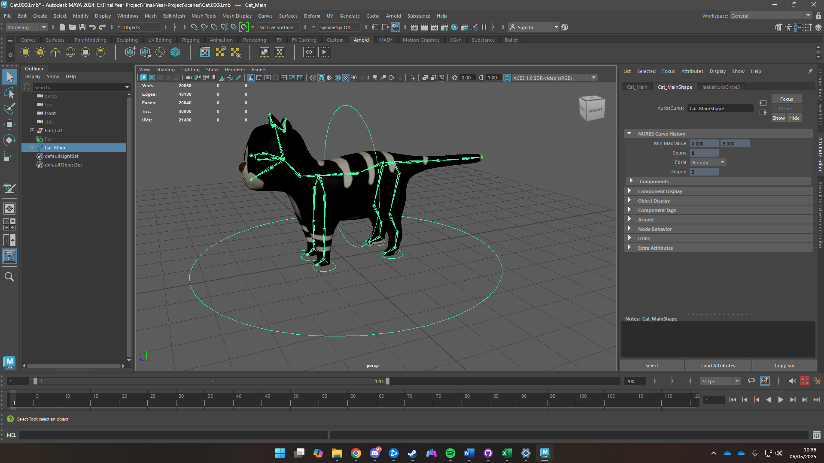

Figure 22 Rigged Character

## Environment Assembly

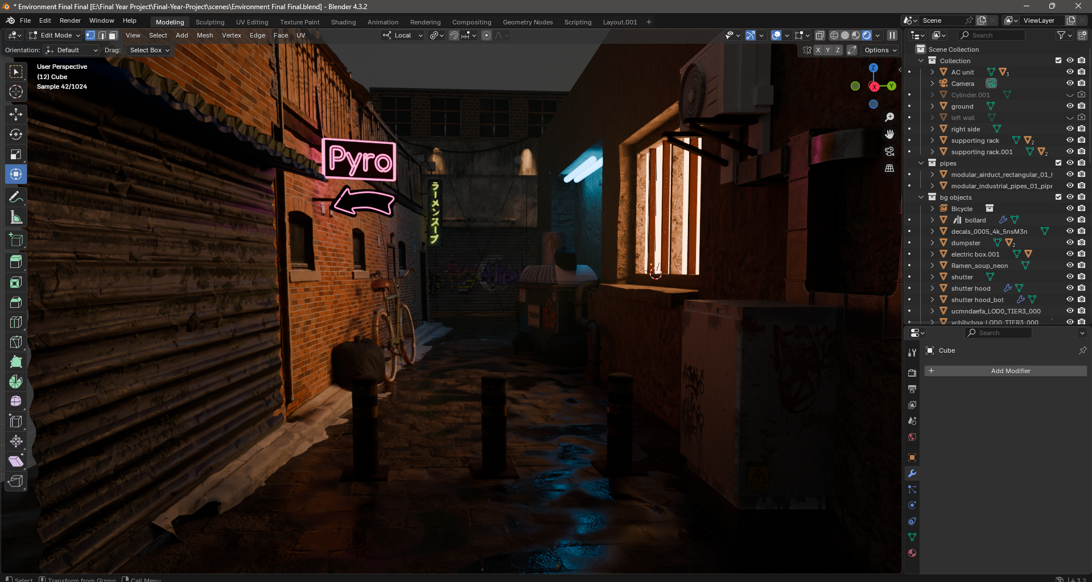

Figure 23 Assembled Scene

# Rendering

# Composing and Editing

# Resources

## Software to be used

### Maya

Used to model the character, animation, lighting, texturing, and rendering.

### Blender

Used for environment modelling, box mapping the environment, along with scene setup with the help of minor assets that were downloaded.

### Adobe Photoshop & Substance Painter

Used for storyboard, texturing of assets.

### After Effects

Used for creating post-production effects.

### Premiere Pro

Compiling footages from the scenes, adding ambient music, exporting the final output.

## Websites Used

### Shutterstock, Istock, Pinterest, ArtStation

Used for references, mood boards.

### Quixel Bridge

Used to download assets

### Polyhaven

Used to download HDRI

## System Requirements

### Drawing Tablet

Wacom Intuous

### Desktop

**Processor:** AMD Ryzen 5 7600x

**Operation System:** Windows 11

**Ram:** 32 Gigabytes

**GPU:** Nvidia RTX 4070 Ti Super

# User Testing and Finding

## Survey Form Results

A total of 11 questions were asked, names and emails were not revealed in the documentation, but follow-up questions were asked personally. The survey was provided after the responders watched the video.

Survey Link: <https://forms.gle/tDqngRJbHQZE6XjS6>

The results are as follows

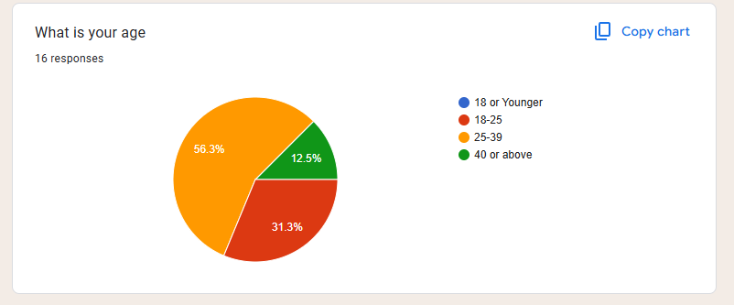

Figure 24 Age Group

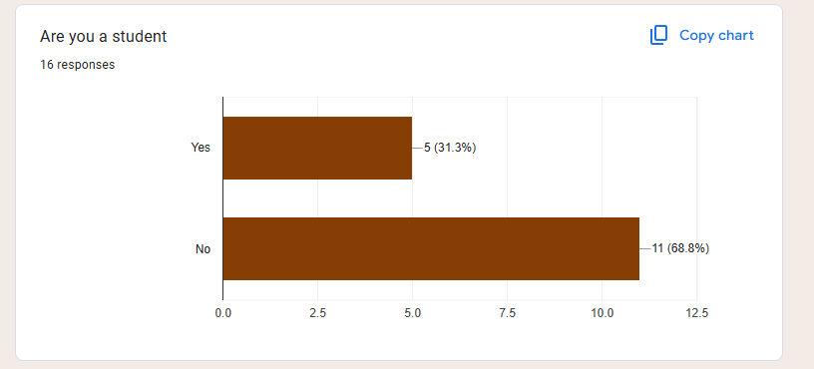

Figure 25 Occupation Status

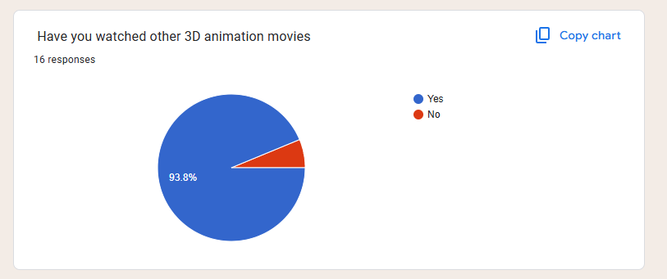

Figure 26 Have they watched other 3D animation movies

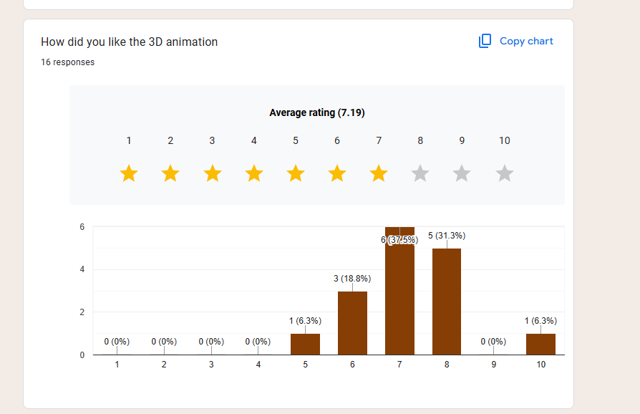

Figure 27 Appreciation of 3D animation

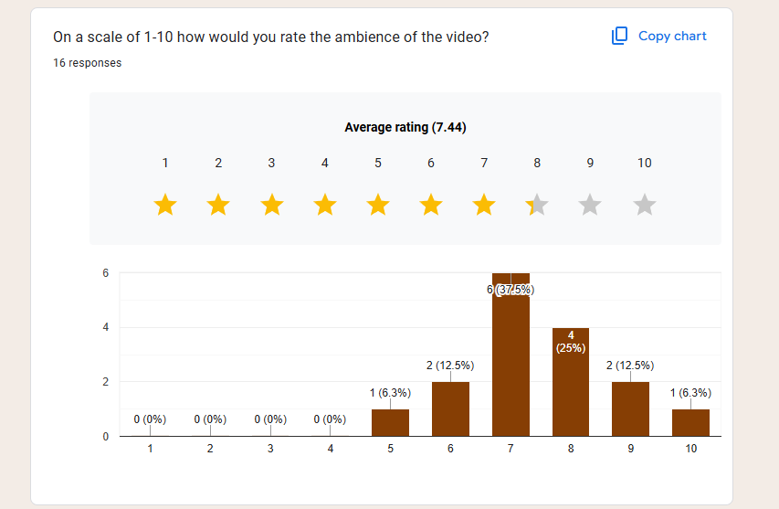

Figure 28 Ambience Rating



Figure 29 Asset Rating

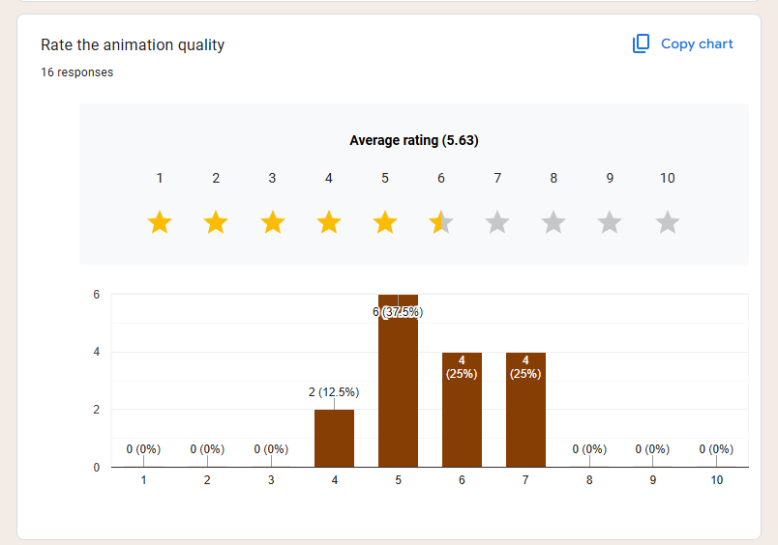

Figure 30 Animation Quality

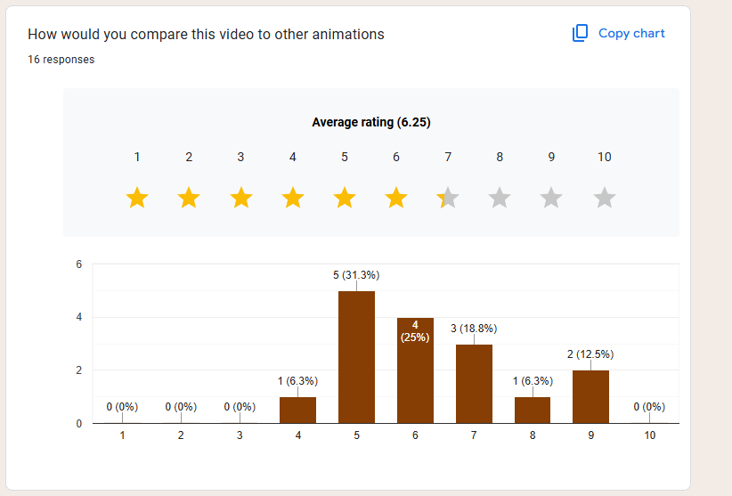

Figure 31 Comparison

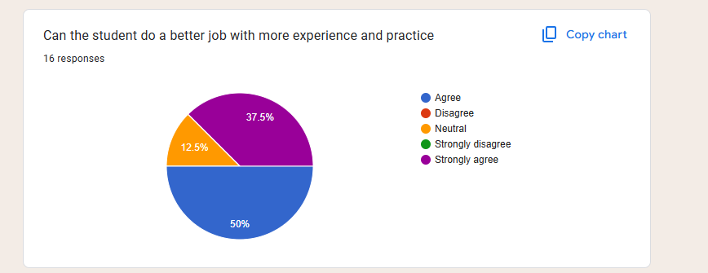

Figure 32 Student Skill

## Third Party Testing

**Eva De Roy (Exports officer at Bundesamt für Wirtschaft und Ausfuhrkontrolle)**

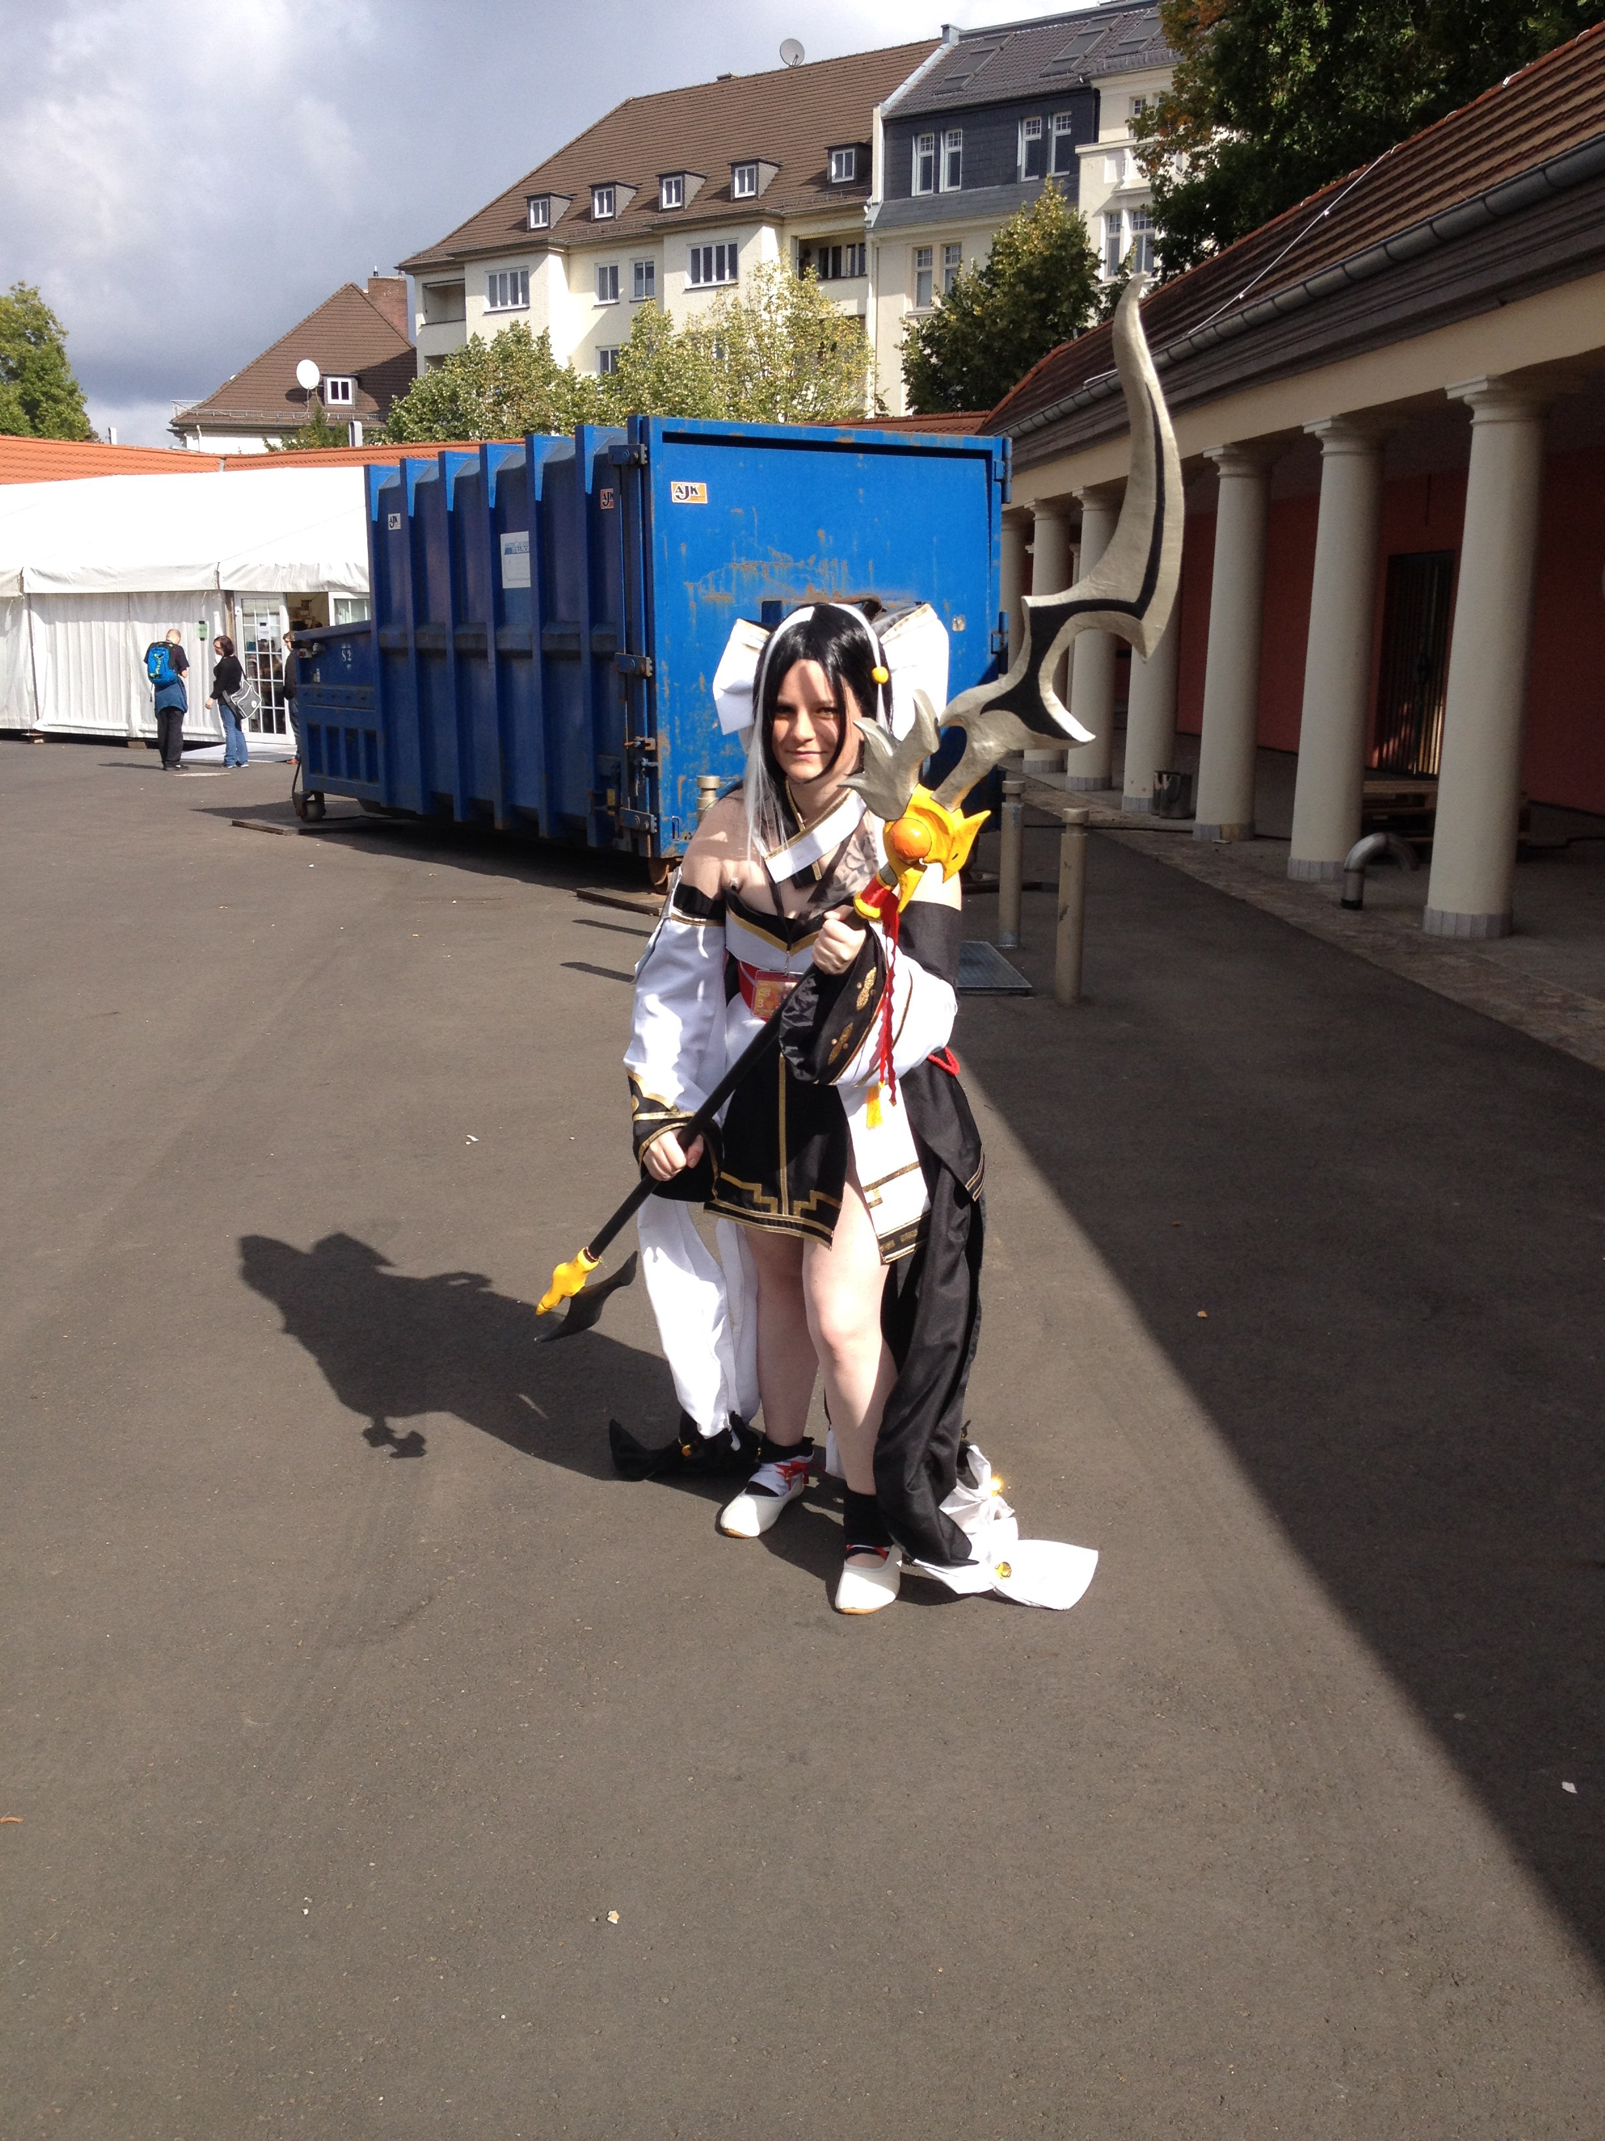

Figure 33 Eva De Roy

The animation looks neat. The aesthetics and mood of the environment look good, and the environment is visually pleasing too. The animation could use some more work as it looks a bit jank. Overall, the effort put in can be seen and it is very commendable. Can’t wait to see what the student will create once he starts working in the industry.

**Prajit Man Shrestha**



Figure 34 Prajit Man Shrestha

The environment and the lighting are mind-blowing. The video in general is properly made. However, the animations were very choppy, and better work could be done on it.

It can be seen that the student has spent a lot of time on making the environment and lighting look good.

**Anna Kasayuke (Project manager)**



Figure 35 Anna Kasayuke

Having known the student for a long time now, it can clearly be seen he has been lazy with some aspects of the 3D animation. The animation could’ve been done much better. However, the environment, lighting, and ambience have hit the spot and look visually stunning.